Instant Pot Pot Roast

Season and Sear the Beef: Start by cutting your chuck roast in half. Season all sides both sides of the beef with salt and pepper. Be generous with your seasoning.
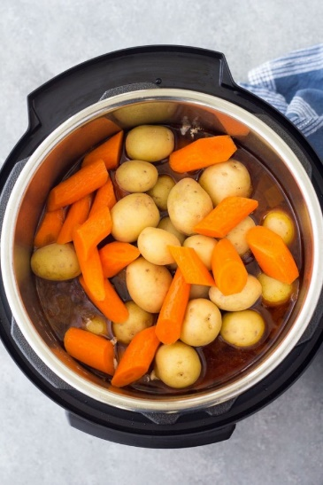
Sear the beef using your Instant Pot’s sauté setting. Browning the beef adds so much flavor. Heat a little bit of olive oil in the pot and add the meat once the pot is hot. While the beef sears, you can chop your onion.
Sauté the Onion and Garlic: Once you have browned the roast on both sides, transfer it to a clean plate and set it aside for a few minutes. Add the onion to the pot and sauté until the onion softens and begins to brown. You can use a spatula or wooden spoon to scrape up any browned bits from the bottom of the pot. Stir in some minced garlic and turn off the Instant Pot.

Deglaze the Pot: Now you are going to add tomato paste, Worcestershire sauce and beef broth to the pot. Stir everything together and make sure that there are no browned bits stuck to the bottom of the pot. This step of deglazing the pan will ensure that you do not get a burn warning during the pressure cooking process.
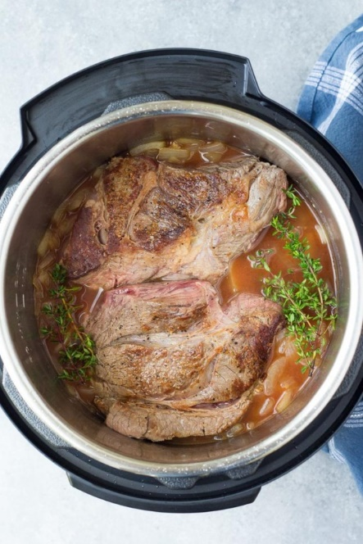
Pressure Cook the Roast: Add the beef back to the pot, along with a few sprigs of fresh thyme. If you do not have fresh thyme you can substitute dried thyme. Close the Instant Pot lid and turn the steam release valve to the sealing position. Set the cook time to 60 minutes at high pressure.
The Instant Pot will take about 10 minutes to reach pressure and then the cook time will begin counting down. Once the cook time ends, allow the pressure to release naturally for 10 minutes and then do a quick release to release any remaining pressure. When the float valve drops down, carefully remove the lid.

Add the Potatoes and Carrots: Now you are going to add your potatoes and carrots. While it may be tempting to add them at the very beginning to save a step, don’t. If you pressure cook your potatoes and carrots for an hour they are going to be really, really mushy.
Add the vegetables to the pot now, on top of the beef. Close the lid and turn the steam valve back to sealing. Pressure cook at high pressure for 10 minutes, followed by a 10 minute natural release.
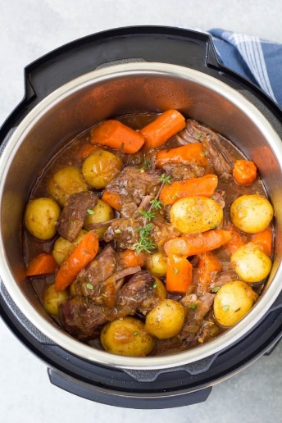
Thicken the Gravy: Thickening the gravy is optional in this recipe. You can serve your pot roast with the juices in the pot as is, or you can make a quick cornstarch slurry to thicken the gravy. It takes about 5 minutes.
To make the gravy, you’ll first need to remove the roast, potatoes and carrots from the Instant Pot. Turn on sauté mode on your Instant Pot. Stir together a mixture of cornstarch and water and stir that into the juices in the pressure cooker. Simmer for about 3 minutes, until the gravy has thickened.

What to Serve with Pot Roast: Serve your pot roast with the gravy. I also like to serve some crusty bread on the side for soaking up extra gravy. A green salad is a nice, fresh addition to this one pot meal.

COOKING A ROAST FROM FROZEN IN AN INSTANT POT
I recommend thawing your pot roast if possible, since you won’t be able to brown a frozen roast and will miss out on the flavor that searing adds to the pot roast. If you don’t have time to thaw, you can cook a frozen roast in your pressure cooker. You will just have to increase the pressure cooking time and skip the step of browning the meat.
Pressure cook a frozen 3 lb. beef chuck roast for 90 minutes, followed by a 10 minute natural pressure release. Then add your potatoes and carrots and pressure cook for 10 minutes more. If your roast is larger than 3 lbs., add 10 minutes per lb. to the pressure cooking time.

COOKING TIPS FOR THIS PRESSURE COOKER POT ROAST RECIPE
- Be sure to follow the recipe directions to pressure cook the chuck roast on its own first before adding the potatoes and carrots. If you add the potatoes and carrots from the beginning, they will become too soft and possibly mushy.
- Pressure cook a fresh 3 lb. roast for 60 minutes at high pressure before adding the vegetables. If your roast is larger, add 10 minutes per lb. to the cook time.
- The best way to reheat leftover pot roast is to heat it in a pot on the stove, covered, over medium heat, adding a little broth or water as needed to thin the gravy. You can also reheat pot roast in your pressure cooker using the sauté setting.

Instant Pot Pot Roast
Instant Pot Pot Roast with tender beef, potatoes, carrots and a flavorful gravy. This easy pot roast recipe is the perfect meal for Sunday dinner.
Prep Time20 mins
Cook Time1 hr 10 mins
Total Time2 hrs 10 mins
Servings servings
Calories430kcal

Ingredients
- 3 lb. beef chuck roast
- 1 1/4 tsp. kosher salt
- 1/2 tsp. black pepper
- 1 Tbl. olive oil
- 1 large onion coarsely chopped
- 1 medium onion, sliced and into quarters
- 5 cloves garlic, minced
- 1 Tbl. tomato paste
- 1 Tbl. Worcestershire sauce
- 1 1/2 cups low sodium beef broth
- 4 sprigs fresh thyme or 1 tsp. dried thyme
- 6 medium carrots cut into 1-inch pieces
- 1.5 lbs. whole baby potatoes
- 2 Tbl. cornstarch

Instructions
- Cut the beef chuck roast in half.
- Sprinkle the salt, pepper and 1 tsp. dried thyme (if not using fresh thyme) on all sides of the beef. (If using fresh thyme sprigs, you will add them later.)
- Heat the olive oil in the Instant Pot using the sauté setting until hot.
- Place the seasoned beef in the pot and brown on both sides, about 4 minutes per side. Do not move the beef until you are ready to turn it; once it has seared it should easily release from the bottom of the pot. After browning the beef on both sides transfer it to a clean plate.
- With the Instant Pot still on sauté mode, add the onion to the pot. Cook until softened and lightly browned, stirring often and scraping up any browned bits from the bottom of the pot, about 4 minutes. Stir in the garlic and press cancel to turn off the Instant Pot.
- Add the tomato paste, Worcestershire sauce and beef broth. Stir and scrape up any browned bits from the bottom of the pot.
- Place the beef back in the pot. If using fresh thyme sprigs add them now.
- Close the Instant Pot lid and turn the steam release valve to the sealing position. Cook on Manual/Pressure Cook, high pressure, for 60 minutes. When the cook time ends, allow the pressure to release naturally for 10 minutes and then quick release any remaining pressure by turning the valve to the venting position.
- Open the Instant Pot and add the carrots and potatoes on top of the beef. Close the lid and pressure cook for 10 minutes more on high pressure using the Manual/Pressure Cook function. When the cook time ends allow the pressure to release naturally for 10 minutes.
- Remove the beef and vegetables from the Instant Pot. Discard the thyme stems. Use two forks to shred the roast into chunks.
- Thicken the juices in the Instant Pot (optional): Turn the Instant Pot on sauté mode. Stir together 2 Tbl.s cornstarch and 2 Tbl.s water in a small bowl and pour into the liquid in the pot. Cook, stirring occasionally, until gravy has thickened slightly.
- Serve pot roast with the gravy.

Notes
- If your roast is larger than 3 lb., add 10 minutes per lb. to the pressure cook time.
- To cook pot roast from frozen, skip the step of browning the meat. Pressure cook a frozen 3 lb. beef chuck roast for 90 minutes, followed by a 10 minute natural pressure release. Then add your potatoes and carrots and pressure cook for 10 minutes more.
- Reheat leftover pot roast in a pot on the stove, covered, over medium heat, adding a little broth or water as needed to thin the gravy. You can also reheat pot roast in your pressure cooker using the sauté setting.

